# M8B

# A1 – INITIAL REPORT

Students:

Yousef Fares: s3955987

Joshua Khoo: s3888831

Jack Gale: s3286616

Emre Altunsu: s3942994

Julian Bayley s3915785

GitHub Repository – <https://github.com/Yousef-Fares/BuildingITSys-AR_M8BIT>

Trello Board – <https://trello.com/b/xUDusjVe/arwed630group1>

A1 – INITIAL REPORT 1

Topic 2

People 3

Aims and Goals 4

Aim 4

Goals 4

Scope 5

Mechanics 5

Distality support. 6

Design 6

Out-of- Scope 6

Project Outcomes 6

Tools and Technologies 7

Unity (v2021.3.7f1) 7

Figma 7

Piskel 7

Adobe Photoshop (23.3.2) 7

Timetable 8

Communication 8

Trello Board 9

GitHub 9

Values 9

Risks 9

Testing 10

Writing Plan 11

## Topic

Chess has reached a point of popularity where the rules and movement of pieces are considered common knowledge amongst the boardgame community but to new players the rules can seem overwhelming (De Marzo & Servedio, 2022). It is M8Bit’s endeavour to make chess easy-to-learn and more accessible to players with disabilities. M8Bit acknowledges that a game of chess can be gruelling, especially to new players, that is why the product will uphold basic chess concepts through achievable mini-games to invokes players with that ‘winning feeling.’

Enthused by the simplicity of New York Times’ Wordle (www.nytimes.com/games/wordle n.d.), M8Bit is to replicate the guessing game’s 6 chance game mechanic to solve a puzzle or fail. Therefore, users will be given a limited number of opportunities to solve the mini-games whereby chances are exhausted by playing an incorrect move or by failing to find the most advantageous manoeuvre. These mini games range from early-game openings, mid-game manoeuvres and end-games victories, and by separating stages of the game into 3 scenarios players can absorb their learnings through the practise of chunking. Often found in musical study, chunking is the learning method of breaking down large pieces of information and grouping them into smaller units to improve information retrieval (Cherry 2020).

The game mechanics involve identical rules and moves (including castling, en passant, etc. (support.chess.com n.d.) as regular chess but M8Bit will harness the sensation of chance to capture a non-chess audience through achievable mini-games. The aesthetic of the game will imitate a nostalgic 8-bit design aligning M8Bit’s easy-to-learn value thus removing the dry and antique theme of original chess.

The primary motivation is to make chess achievable and accessible to everyone. The team plan to increase the chess player base by instructing new users, enticing past players, and retaining the current demographic by developing chess mini-games that invokes that winning feeling.

## People

M8Bit Team

|  |  |  |  |
| --- | --- | --- | --- |
| **Student** | **Interest & Motivation** | **Relevant Skills** | **Role** |
| **Yousef Fares**  (s3955987)   | Fantasising as the playable character and interacting with NPC’s has pushed me to pursue artificial intelligence as a career.  Goal: Explore in-game item interaction with playable characters. | Python, C++, HTML, CSS.  Collaboration, Innovation,  Machine Learning student. | **Software Engineer.**  Develop game via Unity and lead C# discoveries to share with team. |
| **Joshua Khoo**  (s3888831)   | Curiosity over game mechanics that expresses simple creativity and design.  Goal: To explore all platforms of 2D and 3D design. | Python, HTML, CSS, JavaScript, Unity Engine, Piskel.  Design, Interaction, Collaboration. | **Design Lead.**  Develop sprites for in-game mechanics to be manipulated. |
| **Jack Gale**  (s3286616)   | Universe building down to minute detail, unique narratives and composing scores to video games.  Goal: to develop an 8-bit metroidvania game. | Python (Pandas, TKinter), HTML, CSS.  Innovation, Implementation, Clean code. | **Project Manager**  Facilitate discussion to achieve realistic targets that are measurable. |
| **Emre Altunsu**  (s3942994)   | Creative RPG’s that make the player strategise about their end goal.  Goal: To be involved with the game development cycle, with emphasis on producing code and automate testing. | Python, HTML, CSS, SFX.  User-Centred Design, Communication, requirement elicitation. | **Software Engineer**  Communicate what is achievable through the Unity game engine by taking the code and fix framework. |
| **Julian Bayley**  (s3915785) | Dungeons & Dragons and trending technology.  Goal: To shift Dungeons & Dragons to an online platform that users can experience through randomised A.I. dungeon masters. | Python, Java, HTML, CSS.  Troubleshooting, testing, process control, translating tech to non-tech audience. | **Quality Assurance**  Test developments and report constructive feedback to the team identify areas for improvement. |

## Aims and Goals

### Aim

The game of chess has withstood the test of time but to a non-chess audience the rules and the design of the game seem both intimidating and antique, therefore it is M8Bit’s aim to

Increase the chess player base by encouraging new users, challenging old, and to make the game accessible to users with disabilities.

### Goals

1. Attract new users through easy-to-learn mini-games establishing that winning feeling.

Chess can be exhausting at first play, that is why M8Bit plan to break-down stages of the game into user-friendly mini-games. By separating early, mid and endgame scenarios players can absorb the strategy of the game easier through the learning method of chunking.

1. Bring past players back to chess by creating a nostalgic 8-bit design.

Past players considers users who have quit due to the difficulty of chess or users who have refrained from playing for other reasons. To remove the intimidation of chess M8Bit plan to align their easy-to-learn value with an 8-bit design. The 8-bit aesthetic is a game design in the 80’s during the gaming revolution when games were considered simple and consisted of limited functions (Lab 2017). Additionally, M8Bit hope to instil this value in new players by removing the feeling of complexity to a non-chess audience.

1. Make chess more accessible to players with disabilities.

Starting with players who are afflicted with colour vision deficiency, players can use customisable colour wheels changes the colour of the chess board and pieces to make the game viewable.

1. Retain users through competitive leader boards and social media.

By dissecting the data from the mini-games M8Bit will install leader boards by ranking mini-game completion speed and succession rate per number of attempts.

## Scope

M8Bit is a selection of chess mini-games ranging from chess openings, mid game manoeuvres and end-game victories. M8Bit’s mechanics draws inspiration from web-based game Wordle, New York Times’ guessing game that allows users 6 chances to guess the correct word.

M8Bit will prompt users to choose from a selection of chess puzzles to solve, each with their own respective difficulties. M8Bit will mimic Wordle’s simplistic 6 opportunities of chance to guess the solution that’ll be utilized throughout all mini-games; Openings, Manoeuvres and Victories.

### Game Features

#### Openings

The first mini-game will be an Opening challenge where users are presented with the basic chess positions. According to the chosen difficulty, users will need to solve certain opening’s including the first moves found during early-game chess and move pieces within a given number of chances.

#### Manoeuvres

The second mini-game places users in a specific scenario where they’d be expected to follow a certain move order to achieve a better position or piece advantage. This grants the user with several attempts and scenarios with differing difficulties according to the difficulty they selected.

#### Victories

In the third mini-game users play endgame strategies which provide users scenarios where they would follow a certain move order to pronounce checkmate.

M8Bit understands the importance of all 3 states during a chess match; chess matches consist of the early-game, mid-game, and endgame; Solving these scenarios would instil a positive feed-back loop, thus conjuring that winning feeling to keep users playing.

### Distality support.

M8Bit has listened to the wisdom of the crowd in the online chess community and plans to build disability support starting with those afflicted by colour vision deficiency (Colour blind awareness 2022), this can even impact players who cannot distinguish between high contrast colours like black and white. M8Bit plan to design a customisable colour-wheel that changes the colour of the chess board and pieces to help those with vision deficiency.

### Design

Furthermore, M8Bit’s primary unique-selling point may be the unheard-of adaptation of 8-bit to the chess community. We hope to add a certain nostalgic feel for users, whether they’re past, returning, or new, by incorporating an 8-bit design. We find that the 8-bit representation may present itself as a friendlier interface towards users that have never experienced chess before, meanwhile, granting current and returning users a breath of fresh air from the antique interfaces normalized on other platforms. 8-bit cover music will be layered over the top to enhance the experience.

### Out-of- Scope

Implementing social gaming to instil competition via leader boards, creating incentive to keep users coming back and user profiles that could consist of a sign-in and sign-up feature which would grant user’s the ability to save their achievements and progress. This would require the execution of a thorough database and increase the workload on the team.

### Project Outcomes

The project outcomes will reduce the impact of the learning experience on players first play throughs by providing essential tools that would improve their gameplay and in-game awareness. This can be through assisting them in understanding how to place themselves in better positions, or by informing them on popular traps during the early game that would result in a quick loss. Furthermore, by providing a wide range of challenges, users will be exposed to scenarios that cause them to think like a chess player. This allows them to be thrown into an online game and play logically and understand how to calculate the best move sequence. Furthermore, M8Bit will further increase the chess player-base by making practice more available to a large audience. Creating accessibility features, such as different colour themes for colour blind people encourages others to attempt the game and decrease how intimidating it can look at first play.

## Tools and Technologies

### Unity (v2021.3.7f1)

To create our Chess game, we have made the decision to utilise the Unity game engine (latest version 2021.3.7f1). Unity is a free (for personal or student use), cross-platform engine, and has development software available for Windows, MacOS, and Linux. We chose Unity due to it’s relatively beginner-friendly platform and learning criteria in comparison to other engines, and contains a comprehensive feature-set available for developing 2D games. Unity uses the C# code as its main scripting language, which the overall team currently has no experience, with the exception to Josh. Therefore, the team will be tackling a ground-up approach to learn Unity and C# to develop their game.

Joshua has experience using Unity to create 2 different mobile app projects. The first project was a weather application that pulled data from an API, and the second was an AR birthday card app, which used the camera to display an animation overlaid onto a physical card. Both these apps required creating 2D assets, importing them into Unity and creating a navigable user interface which are transferable skills.

### Figma

Figma is a browser-based design software for creating user interface prototypes. We will use this to make mock-ups of our interface designs, beginning with low-fidelity wireframes and refining these until we get to our final polished outcome ready for export. As Figma is web-based, there are no software version numbers, which means everyone will automatically be using the same version. Each team member has some experience using Figma to create mobile interface prototypes for user-centred design standards.

### Piskel

Given our art-style is going to be a retro, 8-bit game we will need to create pixelated game pieces. Piskel is a browser-based pixel art creator that can be used to create the sprite assets for our game, such as the pieces and chess board. It could also be used to create some of the interface elements to create a consistent look. Similarly to Figma being web-based there are no version numbers for this tool.

### Adobe Photoshop (23.3.2)

If any changes to the sprites need to be made that can’t be done due to limitations of Piskel, Adobe Photoshop can be used to make small adjustments. After creating spites in Piskel, Photoshop can composite them into a single image or scene, for example to create a background for the chess board.

## Timetable

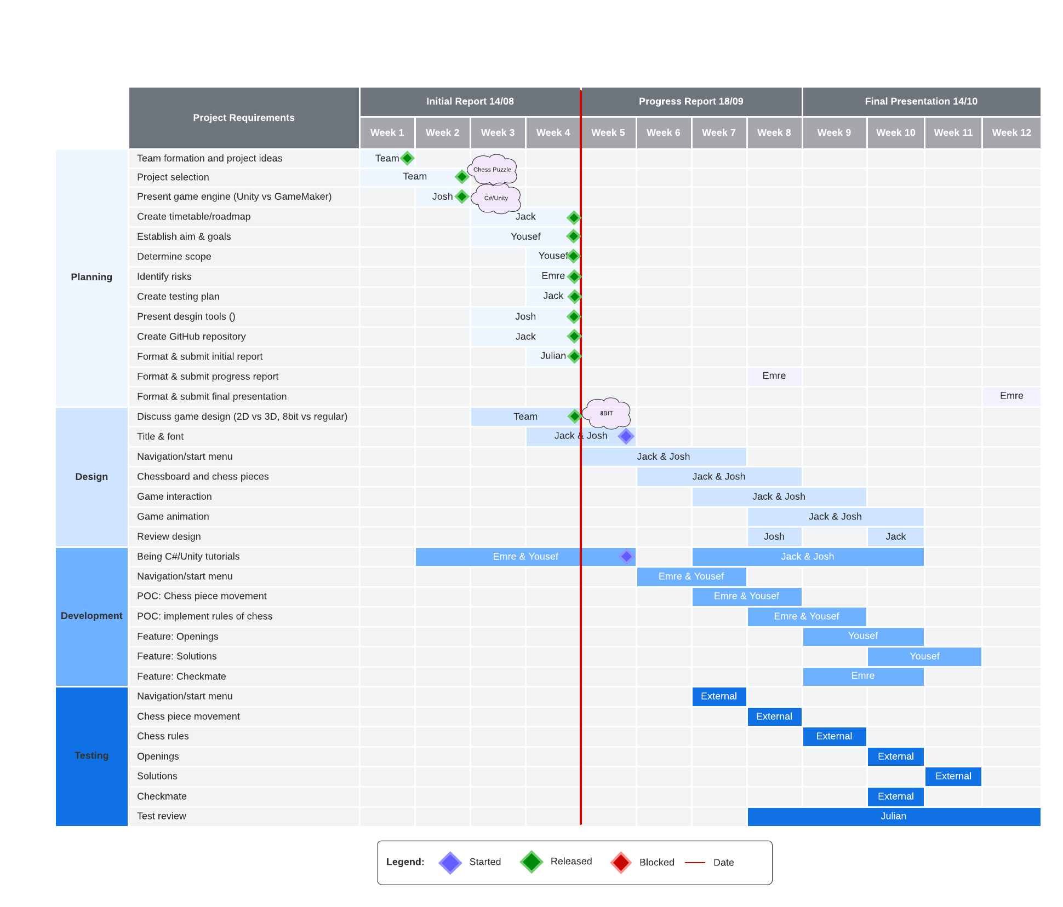Reflected as a Gannt chart the timetable below explores 4 key stages of the Software Development Life Cycle (Jevtic 2019). The team has decided to take an assembly line approach planning, design, development and testing to allow for risk mitigation and unpredictable variables. The current plan is to finish by week 11 to cater for any unforeseeable changes.

M8Bit Gannt Chart

### Communication

|  |  |  |  |  |  |
| --- | --- | --- | --- | --- | --- |
| **When** | Mon/Wed | **Start** | 17:00 | **End** | 18:00 |
| **Room** | MS Teams | **Chair** | Rotated | **Trello** | Individual |

Meetings are held every Monday and Wednesday at 17:00 during a recorded Microsoft Teams chat room. The purpose of each meeting is to discuss each action item and assign tasks to team members reflected on the Trello Board. Any items not listed in Trello will be left to discuss at the end of the meeting.

Decision-Making

The decision-making process will adhere to majority vote. Each group member will support their decision with a SWOT analysis or an alternative decision-making matrix to help the group align their vision. Group members must favour outcomes that support real-world scenarios that gain experience to enter the workforce.

Absence

If an attendee is absent the group must follow these steps.

1. Invite absentee to meeting to prompt call hunting.
2. Wait for absentee to provide developments in Teams Channel and Trello.
3. Absentee to review next action item on Trello (group or individual).
4. If absentee is unsure of next action, then they must contact the group via MS Teams.

### Trello Board

The Trello Board is the source of truth and will act as the team’s agenda. Individuals must update their own action items in their respective Trello cards. Stand-up will be conducted at the beginning of every meeting to address developments, insights, and concerns.

### GitHub

All supporting media to the project must be committed to the groups GitHub repository. Commits are to be detailed with collaborator comments recording trails of change. Any major change to code files must be communicated to the team to avoid loss of work.

### Values

To achieve successful collaboration between team members the following values must be upheld to ensure a safe and respectful environment.

1. Open-Discussion – All ideas are considered great ideas as they encourage discussion and challenge ways of thinking. Each idea presented by the group must be supported with a reference or a source to uphold the RMIT academic integrity awareness.
2. Transparency – Every task listed in Trello must be completed to aid the project. Team members must be honest with themselves and the group to deliver realistic targets. Any encountered roadblocks must be communicated to the team to avoid wasting the efforts of others.
3. Respect – Communication should be expressed with consideration to cultural similarities and differences to establish a shared vision that is translatable and deliverable from all team members
4. Clean code – Code must be cleaned by tagging functions and elements with accurate comments and labelling variables with distinct easy to understand actions so that anyone can pick-up where the author left their work.

### Risks

Unearthed during open conversation between team members, many roadblocks and deficiencies in programming skills, including access to necessary software have been identified. It has become clear that the majority of team members have limited knowledge regarding the utilization of the C# programming language. Although, attempts to recompensate have been made through regular practice with W3 Schools, video tutorials from the Epitome YouTube Channel, and a structured approach from Harrison Ferrone’s ‘Learning C# by. Developing Games with Unity 2021.’

Furthermore, Unity as a game development tool contains various features, all of which are highly sophisticated and complex. This conjures a multitude of risks applying any and all required Unity based concepts across the entire development process, in addition to learning and applying the complementary C# code.

Another major collective aspiration is to implement support features toward visually impaired individuals, more specifically those impaired with colour vision deficiency. Attaining information in regard to the colour-blindness spectrum and accurately emulating associated colours in Unity may require some compromise and therefore creates various limitations in design and structure of the general program. Such difficulties may impact overall group efficiency alongside possible degradations in motivation, time management skills and most importantly the successful and satisfactory completion of all project components prior to final submission.

### 

### Testing

Writing test cases will be a collaborative effort between the management team and the development team. This agreement between the two groups strengthens the accuracy of the original test cases and allows additional test requirements discovered during development to challenge the product. The two teams working together create the opportunity to deliver test cases that are executable by a non-tech audience.

#### Test Case Requirements

Test cases are to be executed by an external audience from the project team, preferably by another group at university studying Building IT Systems (COSC2625) at the Royal Melbourne Institute of Technology. Once test cases are finalised the Quality Assurance Engineer will conduct a review and translate the feedback to the management team.

|  |  |  |  |  |  |
| --- | --- | --- | --- | --- | --- |
| **Created** | Team | **Executed** | External | **Date** | Week 7 - 11 |
| **Where** | Online | **Platform** | MS Teams | **Browser** | Chrome Safari |

#### Test Cases

M8Bit Test cases

|  |  |  |  |
| --- | --- | --- | --- |
| **Date** | **Test Case** | **Scenario** | **Pass/Fail** |
| Week 7 | Navigation | User can navigate start/menu without crashing application. |  |
| Week 7 | Navigation | User can navigate between chess mini-games without crashing application (Openings, Maneuverers, Victories) |  |
| Week 8 | POC | User can move chess pieces on chessboard. |  |
| Week 9 | POC | User can play a game of chess. |  |
| Week 10 | Openings | User can play a randomised series of chess randomised early-game scenarios. |  |
| Week 10 | Maneuverer | User can play a randomised series of chess mid-game scenarios. |  |
| Week 11 | Victories | User can play a randomised series of chess end-game scenarios |  |

### Writing Plan

Reporting, timetabling, and managing Trello cards are a shared task among the team, but certain reporting components will be weighted toward the role that’s aligned with each team member’s responsibility.

The Project Manager and the Product Owner uphold the vision and steer the project on-course by managing workflow and business requirements, this is reflected by establishing the project goals, aims, scope and risks. Additionally, they will take control of design and review development testing and incorporate the feedback into the application and final report.

The Software Engineers and the Quality Assurance play a pivotal role communicating their developments to the team by recording technology insights and roadblocks they encounter throughout the project. During the testing phase of the project the development team must collaborate with the management team to create user-friendly test cases that are translatable and accessible to a non-tech audience.

**References**

**De Marzo, G. and Servedio, V.D. (2022). Quantifying the complexity and similarity of chess openings using online chess community data. arXiv:2206.14312 [cond-mat, physics:physics]. [online] Available at: https://arxiv.org/abs/2206.14312 [Accessed 11 Aug. 2022].**

**www.nytimes.com. (n.d.). Wordle - A daily word game. [online] Available at: https://www.nytimes.com/games/wordle/index.html.**

**Cherry, K. (2020). How the Chunking Technique Can Help Improve Your Memory. [online] Verywell Mind. Available at: https://www.verywellmind.com/chunking-how-can-this-technique-improve-your-memory-2794969#:~:text=Chunking%20refers%20to%20the%20process.**

**support.chess.com. (n.d.). How do I Castle? - Chess.com Member Support and FAQs. [online] Available at: https://support.chess.com/article/266-how-do-i-castle.**

**Lab, W.B. (2017). The Evolution of Gaming: The Rise of the 8-Bit Era. [online] Wired. Available at: https://www.wired.com/brandlab/2017/04/evolution-gaming-rise-8-bit-era/.**

**Colour Blind Awareness (2022). Colour Blindness. [online] Colour Blind Awareness. Available at: https://www.colourblindawareness.org/colour-blindness/.**

**Jevtic, G. (2019). What is SDLC? How the Software Development Life Cycle Works. [online] PhoenixNAP Global IT Services. Available at: https://phoenixnap.com/blog/software-development-life-cycle.**